**Astrodynamics Standards**

**Version 8.0**

**Release Notes**

**October 2020**

**HQ U.S. Space Force**

**A3/6Z**

**Astrodynamics**

**Standards**

**Engineering**

**Group**



**DISTRIBUTION E:** Distribution authorized to DOD components only (test and evaluation) 17 Aug 2017. Other requests for this document shall be referred to AFSPC SMC/SYF or HQ AFSPC/A5M.

Contents

1. Background 1

2. What’s New 1

3. Document Overview 1

3. Astro Standards Library Bug Fixes and Enhancements 8

3.1 AOF - Area Overflight 8

3.2 AstroFunc - Astrodynamics Functions 8

3.3 BAM – Breakup Analysis Module 8

3.4 BatchDC - Batch Differential Correction (DC) Orbit Determination 8

3.5 Combo - Computation of Miss Between Orbits 9

3.6 DllMain - Main Library 9

3.7 ElComp - Element Comparison, including Computation of Co-Orbital 9

3.8 ElOps - Element Operations 10

3.9 EnvConst - Environmental Constants Utility 10

3.10 ExtEphem - External Ephemeris 10

3.11 FOV - Field of View 10

3.12 Lamod - Look Angle Module 11

3.13 Obs – Observations 11

3.14 ObsOps - Observation Operations 12

3.15 Rotas - Report Association, Observation/Element-Set Association 12

3.16 SAAS - Space Attack Assessment Software 13

3.17 SatState - Satellite State 13

3.18 Sensor – Sensor Processing 14

3.19 Sgp4Prop - SGP4 Propagator, extended to include SGP4-XP Capabilities 15

3.20 SpProp - SP Propagator 16

3.21 SpVec - SP Vector 17

3.22 TimeFunc – Time Functions 17

3.23 TLE - Two-Line Element Set Processing 17

3.24 VCM - Vector Covariance Message Processing 18

4. Past Releases of the Astrodynamics Standards 19

5. References 19

Figures

Figure 1. What’s New: Algorithm Upgrades for Version 8.0 2

Figure 2. What’s New: Environment/Processing Upgrades for Version 8.0 3

Figure 3. What’s New: SGP4-XP Extended Perturbations 4

Figure 4. Benefits of using SGP4-XP instead of SP at the Sensor Sites 4

Figure 5. Key things to know about the SGP4/SGP4-XP Release 5

Figure 6. Astodynamic Standards Distribution 5

Figure 7. Astrodynamic Standards Version 8 Architecture (New) 6

Figure 8. Astrodynamic Standards Version 7 Architecture (Old, included for reference) 7

Figure 9. GP Theory and Ephemeris Types Reference Table. 15

# 1. Background

Version 8.0 is a major new release of the U.S. Space Force, Space Operations Command, Astrodynamics Standards software library. The Astro Standards are delivered as a collection of Dynamic Link Libraries (DLLs) for Windows and Shared Objects (SOs) for Linux. Within this document, the term Library is used to refer to either a Windows DLL or a Linux SO. The Library algorithms are designed to be compatible with algorithms used in space operations. The Astro Standards are used to Verify and Validate (V&V) equivalent algorithms of operational systems such as those that run at the 18th Space Control Squadron (18th SPCS) at Vandenberg AFB, and other operational locations critical to the National defense.

# 2. What’s New

The overall architecture for Version 8 has been streamlined and improved. In all, there are 40 new Application Program Interfaces (APIs) added to the Library. The Simplified General Perturbations Version 4 (SGP4) propagator now includes major new capabilities in the form of extended perturbations (XP) producing significant accuracy improvements over prior versions of SGP4 for all orbit regimes. This new advanced version of the SGP4 propagator is referred to as “SGP4-XP”. The Look Angles capability LAMOD has been upgraded to include sensor configurations such as for the ORS‑5 (Sensorsat) dome-segment-like field of view (FOV) and the Space Fence complex Field of View (FOV) and Field of Regard (FOR) according to detailed azimuth-elevation segment definition tables. A new triangulation-algorithm produces range observations using simultaneous tracks from two angles-only sites. These and other major new capabilities are covered within.

On the back-end, the ongoing software engineering of the Astro Standards Library now operates under *Continuous Integration Continuous Deployment* (CICD) that automatically merges all developers’ working copies to the Release. This automated and formalized build process packages the Release to ITAR for delivery to users while running Verification and Validation of the driver examples to ensure the Release runs on both Windows and Linux 32- and 64-bit platforms, for all of the wrapper-environment languages supported including C/C++, C#, Java, Python 2, Python 3, VB .net, Fortran, and MATLAB. The driver examples have been improved for consistency and use-ability, and the delivery package reproduces the driver executables for each of the seven languages supported.

# 3. Document Overview

**Figure 1** summarizes the major new algorithm capabilities of Version 8.0.

**Figure 2** summarizes the environment/processing upgrades of Version 8.0.

**Figure 3** summarizes specific extended perturbations (XP) and other capabilities of the new SGP4-XP.

**Figure 4** lists the benefits of using SGP4-XP instead of SP at the sensor sites.

**Figure 5** lists key things to know about the SGP4-XP release.

**Figure 6** provides information about the distribution of new releases of the Astrodynamics Standards.

**Figure 7** shows the new V8 architecture as modified to a) merge capabilities of the prior Computation of Co-Orbital (COCO) and Element Comparison (ELCOMP) applications into the ELCOMP library; and b) better organize the overall set of library dependencies throughout the architecture.

**Figure 8** for reference against the new architecture shows the architecture as it existed for V7.

**Section 4** follows with a breakdown of the specific Bug Fixes and Enhancements for each Application, Utility, and Astro Function library and identifies cases for which APIs are changed or new.

|  |
| --- |
| 1. This is a major release due to the change to the Astro Standard library’s dependency rule as depicted in the new architecture of **Figure 7** versus the old architecture of **Figure 8**. While C#, VB .net, and Java resolve these dependencies automatically, other supported languages require the library to be loaded in the new top-down dependency order depicted in **Figure 7** (New). 2. Capabilities of the old Computation of Co-Orbital (COCO) and Element Comparison (ELCOMP) applications are now merged to the ELCOMP library with the Element Operations (ElOps) library dependency. 3. The new SGP4-XP includes Extended Perturbations (XP) to the SGP4 propagator as summarized in **Figures 3 and 4**. To ensure backward compatibility, there is a new ***Ephemeris Type 4 (XP)*** *now* accommodated by the TLE that allows users to use legacy SGP4 Ephemeris Types 0 or 2, or SGP4-XP Ephemeris Type 4 TLEs without changing inputs to the SGP4prop library. This keeps interfaces from changing due to the XP upgrade. 4. Version 8.0 includes an *Extrapolation-GP Differential Correction* capability (a.k.a., “*Extrap-GP*” or “*eGP*”). This new capability allows users to create an SGP4 or SGP4-XP element set fit to the SP ephemeris from an SP Vector. 5. Sensor configurations and the Look Angles capability allows two new sensor types to specify the Space Fence Field of View (FOV) and Fields of Regard (FOR), and the dome-segment-like FOV for the ORS-5 (Sensorsat). 6. Version 8.0 allows use of the 18th SPCS Astrodynamics Standards Workstation (ASW) sensor files, which include current sensor locations, weights and biases. 7. A new triangulation technique is implemented to provide range observations using simultaneous tracks from two angles-only sites. For more information see white papers “*A Short Evaluation of Triangulated Range from Multiple Angles-Only Sites,*” [Slatton, 2014]**1**; and “*Applications of Simultaneous Tracking with Optical Sensors,*” [Slatton, Butkus, Bruck, 2019]**2**. 8. Version 8.0 implements the King-Hele decay algorithm to predict the expected lifetime of orbital objects based on current solar parameters and TLEs. For more information, see non-published white paper “*Technical Description of the KH Program,*” [Jaszkowiak, 2008]**3**, available upon request to the MITRE Corporation. 9. Rotation of Right Ascension/Declination now allows rotation to a different epoch. 10. Kozai and Brouwer mean motion conversions always use WGS-72 regardless of the setting of Earth constants. This ensures consistency with legacy and current operational practices. 11. Version 8.0 accommodates use of operational comma-separated values (csv) format observations and element sets. These csv formats allows for higher precision and more information. Additional fields of the csv format may cause the need for interface changes. This csv capability is the C2 answer to processing the “9-digit” Catalog numbering scheme. In the meantime, operational legacy messaging is still being addressed as of this Release 8.0. |

Figure 1. What’s New: Algorithm Upgrades for Version 8.0

|  |
| --- |
| 1. 40 new APIs were added to the library. See subsections of Section 3 that identify the specific new APIs for each library, where applicable. In all, there are now 557 APIs across 24 libraries. 2. Continuous improvements for thread safety and efficiency. When appropriate, shared data is copied to each thread so it does not need to wait until the shared data becomes available, thereby improving overall performance. 3. Javadoc is now included with the release. This single document includes Javadocs for all libraries. Overall Astro Standards documentation is updated and improved. 4. The Driver examples’ folder structure is reorganized to follow the common industry practice. 5. New Driver examples have been added for Python 2 and Python 3. 6. C# unit tests are provided to end users. In lieu of Driver examples, C# unit tests are included and being provided to end users as a quick example of the API usage. 7. Auto testing of the driver examples is improved to ensure all Drivers work properly on all architectures (32-bit and 64-bit) and platforms (Windows/Linux) before being added to the distribution packages. 8. The Driver examples build process is also improved to include scripts, solution, and make files thereby facilitating the reproduction of the driver executables using the provided source code. 9. More driver examples have been added for the Linux platform. 10. Fortran POINTER variables have been replaced with ALLOCATABLE, when appropriate, to improve library performance and reduce the possibility of memory leaks. 11. Leading blanks in satellite numbers are now replaced with zeros, for consistency in satellite numbering conventions used for both observations and element sets. 12. An issue is resolved that occasionally resulted in program-crash due to no input records for the Obs, ExtEphem, Tle, SpVec, and Vcm Linux SOs. 13. The *Save Partials* flag is now defaulted to **OFF** for SP Propagation. With the Save Partials flag turned Off, Covariance (orbital position uncertainty) is *not* propagated during the run. Propagation of Covariance is a CPU- and RAM-intensive process that most users do not need to invest for routine SP-propagation and conjunction assessment needs. The *Save Partials* should be turned **ON** only by users that need computed Probabilities of Collision Pc from COMBO runs. *This single default to OFF for the Save Partials flag reduces COMBO run-times by 50-60%.* 14. *Other Windows-specific* performance upgrade: Windows applications are prevented from automatically using more than one CPU core. This new restriction reduces overhead by eliminating auto-parallel processing and significantly improves overall performance. 15. *Other Java/Linux-specific performance upgrade*: “Segfault” issues with java applications due to not enough stack size is resolved. Java user/integrators should no longer need to use the “*–Xss*” parameter in the JVM to fix this issue. |

Figure 2. What’s New: Environment/Processing Upgrades for Version 8.0

|  |
| --- |
| 1. Improved Lunar perturbation modeling. 2. Resonance is now better modeled for existing orbit regimes including one- and one-half day orbits (GEO and GPS). One-half day resonance modeling now also includes half-day orbits other than Molniya highly elliptical orbits. Plus, there is now resonance modeling for eight- and sixteen-hour orbits. 3. Added Solar Radiation Pressure modeling. For the new Ephemeris Type 4 TLE, the AGOM model parameter resides in the $\ddot{n}/6$ location of the legacy Ephemeris Type 0 and 2 TLEs. AGOM resides in Line 1, column positions 42-52, with the leading decimal point assumed. 4. The new Ephemeris Type 4 TLE uses the *Brouwer* mean motion. Brouwer mean motion resides in Line 2, column positions 53-63. For reference, Ephemeris Type 0 SGP element sets include the *Kozai* mean motion; and Ephemeris Type 2 element sets include *Brouwer* mean motion. 5. The J5 zonal has been added to the Geopotential modeling for SGP4-XP for consistency with the PPT3 theory and the original Brouwer work. 6. For Ephemeris Type 4 TLEs, deep-space perturbations are now always included. The legacy 225-minute period threshold no longer applies. 7. The Very Deep Space (VDS) / *cislunar* region is added for multiday orbits. 8. For Ephemeris Type 4 TLEs, EGM-96 replaces the WGS-72 Earth and Geopotential models, to be consistent with operational-grade ASW/SP modeling. 9. The Jacchia-70 atmosphere density model for drag replaces the static atmosphere model. The atmosphere model now uses a generic flux model that fits historical flux and Ap geomagnetic indices dating back to 1947. It also predicts flux forward in time based on the historical periodics. With this new implementation, there is no need to maintain F10 and Ap indices as inputs to the propagator. 10. The new Ephemeris Type 4 TLE replaces the B* drag term with the B term. The B term for ephemeris Type 4 TLEs resides in Line 1, column positions 54-61, and the leading decimal point assumed. |

Figure 3. What’s New: SGP4-XP Extended Perturbations

|  |
| --- |
| 1. Legacy SGP4 analytic-solution propagation is substantially faster than SP propagation by numerical integration, but legacy SGP4 is significantly less accurate than SP. 2. In contrast, the new SGP4-XP accuracy is statistically equivalent to that of SP, but SGP4-XP performance is not much slower than Legacy SGP4. SGP4-XP run times are approximately 1.5x longer than SGP4 for deep-space propagation and 2x longer for orbits in the drag regime. 3. SGP4-XP uses existing TLE structure with new Ephemeris Type 4. 4. Given that TLEs are already a long-established standard message used by sensor sites, SGP4-XP accuracy improvements can be quickly realized by the sites without expensive costs per site to implement a new message type. 5. SGP4-XP is significantly better for sensor tasking, observation association, and tracking by optical and radar sites. It is expected to significantly reduce the occurrence of false uncorrelated tracks. |

**Figure 4. Benefits of using SGP4-XP instead of SP at the Sensor Sites**

|  |
| --- |
| 1. Astro Standards Version 8.0 will have SGP4-XP as part of the *non-restricted* SGP4 library. 2. The Version 8.0 SGP4 library inherently includes legacy capabilities of SGP4 (via Ephemeris Type 2) as well as the new SGP4-XP extended perturbations (via Ephemeris Type 4). Version 8.0 is being released to <https://www.space-track.org> as well as the SARP website: [https://halfway.peterson.af.mil/SARP](https://remote.parsons.com/https/urldefense.proofpoint.com/v2/url?u=https-3A__halfway.peterson.af.mil_SARP&d=DwMGaQ&c=Nwf-pp4xtYRe0sCRVM8_LWH54joYF7EKmrYIdfxIq10&r=3RQvJbIj5vYrchqfwVb2V_Kbju6AIAMvXiI34ei92j0&m=470Udk9vtga-CX1WjUNToLA1VAZfC8qAYnJ9KF8aNA0&s=uUrk8vXvEcJ3CkJ0cw8emoImpIRccgFEEFOGhuXGZPQ&e=). 3. TLEs will continue to be generated by the 18th SPCS *CAVENet* and included in the daily-products job for uploading of current obfuscated two-line element sets to [space-track.org](https://www.space-track.org) (see below for permissions information). 4. The SGP4 library will know which algorithm to use (legacy SGP or SGP4, or SGP4-XP based on ephemeris type setting of 0, 2 or 4 respectively). *There is no need to change interfaces to current programs that use SGP4.* 5. Given this is a new capability, out of an abundance of caution, it is extremely important to continue to use the most current version of the SGP4 library in the event the SGP4-XP changes. If changes are required for any reason, changes may not be backward compatible with prior versions of SGP4-XP. Future version updates could contain bug fixes as well as improvements and may not be backwards compatible with prior versions of SGP4-XP. Experimentation and parallel runs are encouraged to provide insight into the modeling improvements. |

Figure 5. Key things to know about the SGP4/SGP4-XP Release

|  |
| --- |
| **For the SGP4/SGP4-XP Propagator:**   1. The fastest way to obtain SGP4/SGP4-XP is by creating an account on [https://www.space-track.org](https://remote.parsons.com/https/www.space-track.org/), and downloading it directly from there. No approval is required, but permissions will need to be granted by the administrators of space-track.org. 2. SGP4 is one unique Astro Standards application in the suite of Astro Standards applications available in that it is U.S. Space Force, Space Operations Command-approved to “share with the world.”   **Other Applications within the Astro Standards Library (including SGP4/SGP4-XP):**   1. For the balance of the Astro Standard Applications, use [https://halfway.peterson.af.mil/SARP [halfway.peterson.af.mil]](https://remote.parsons.com/https/urldefense.proofpoint.com/v2/url?u=https-3A__halfway.peterson.af.mil_SARP&d=DwMGaQ&c=Nwf-pp4xtYRe0sCRVM8_LWH54joYF7EKmrYIdfxIq10&r=3RQvJbIj5vYrchqfwVb2V_Kbju6AIAMvXiI34ei92j0&m=470Udk9vtga-CX1WjUNToLA1VAZfC8qAYnJ9KF8aNA0&s=uUrk8vXvEcJ3CkJ0cw8emoImpIRccgFEEFOGhuXGZPQ&e=). The requestor must have a U.S. Government-issued CAC card and be logged into *NIPRnet* or *SIPRnet*. This website cannot be accessed from the Internet. 2. Once logged-in to [https://halfway.peterson.af.mil/SARP [halfway.peterson.af.mil]](https://remote.parsons.com/https/urldefense.proofpoint.com/v2/url?u=https-3A__halfway.peterson.af.mil_SARP&d=DwMGaQ&c=Nwf-pp4xtYRe0sCRVM8_LWH54joYF7EKmrYIdfxIq10&r=3RQvJbIj5vYrchqfwVb2V_Kbju6AIAMvXiI34ei92j0&m=470Udk9vtga-CX1WjUNToLA1VAZfC8qAYnJ9KF8aNA0&s=uUrk8vXvEcJ3CkJ0cw8emoImpIRccgFEEFOGhuXGZPQ&e=) obtain additional details by referring to the document, “**Instructions for Requesting Astrodynamics Standards Software.pdf,”** available upon logging into the SARP website. |

Figure 6. Astodynamic Standards Distribution

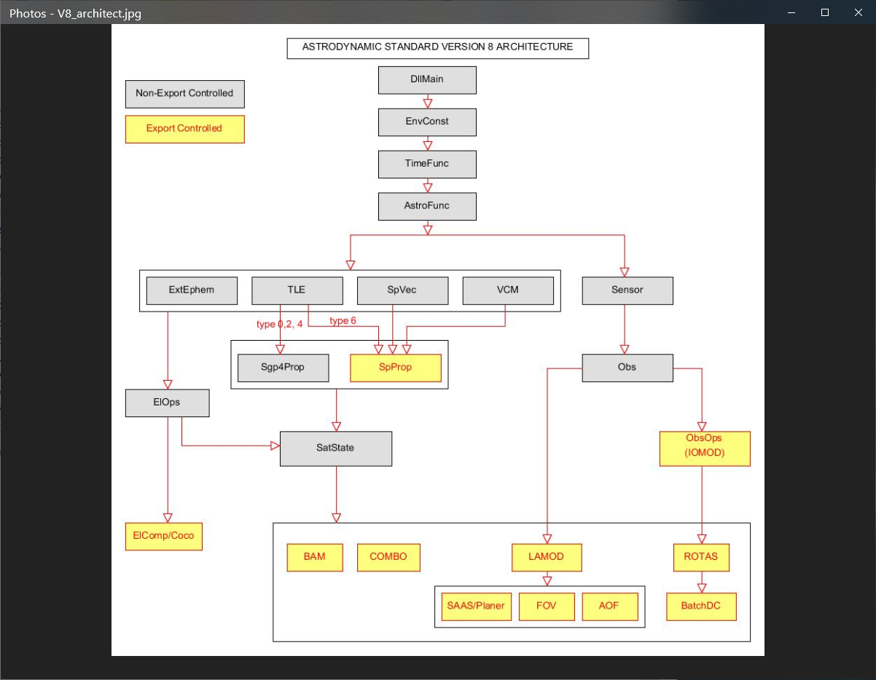

Figure 7. Astrodynamic Standards Version 8 Architecture (New)

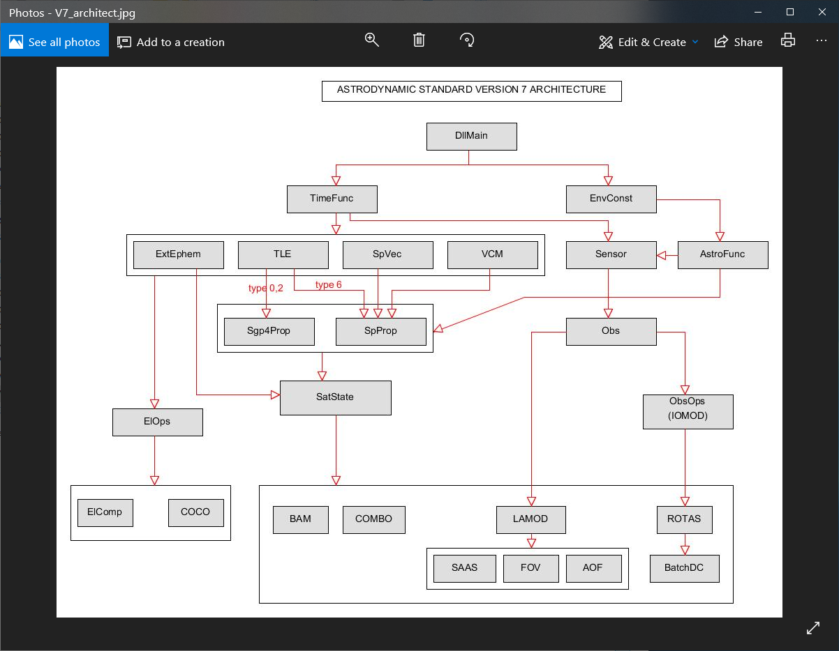

Figure 8. Astrodynamic Standards Version 7 Architecture (Old, included for reference)

# 3. Astro Standards Library Bug Fixes and Enhancements

The following subsections are listed alphabetically by each of the 24 Astro Standards libraries for quick reference. The precise library name is shown before the “-“ in the section heading and corresponds directly to the library names used in Figure 7 of the new architecture for Version 8.0.

## 3.1 AOF - Area Overflight

AOF computes when overhead satellites have potential visibility to a geographic location or area on the surface of the Earth. Visibility is defined as a nominal Field of View (FOV), defined by a user-specified half-angle around the satellite's sub-point intersecting the defined points or areas on the surface.

***No changes to AOF for Version Release 8.0***

## 3.2 AstroFunc - Astrodynamics Functions

This library includes various Astrodynamics functions for orbital element conversions; coordinate transformations and reference-frame transformations.

**Added new APIs to AstroFunc:**

* 1. ***RotRADecl***: Rotates Right Ascension and Declination to the specified epoch.
  2. ***RotRADec_DateToEqnx***: Rotates Right Ascension and Declination from TEME of Date to MEME of the specified year of equinox.
  3. ***RotRADec_EqnxToDate***: Rotates Right Ascension and Declination from MEME of the specified year of equinox to TEME of Date.

## 3.3 BAM – Breakup Analysis Module

The Breakup Analysis Module library uses the last good element set of the parent object along with user-selected best-quality element sets of a few of the breakup pieces. The post-breakup piece element sets are propagated backward in time, and the pre-breakup parent element set is propagated forward in time, to identify the "pinch-point" where the piece and parent element sets converge positionally in time. This convergence point corresponds to the time the breakup of the parent most likely occurred.

***No changes to BAM for Version Release 8.0***

## 3.4 BatchDC - Batch Differential Correction (DC) Orbit Determination

BatchDC Performs a least-squares batch differential correction of orbital elements using empirical tracking data (sensor observations). It updates either SGP4 Keplerian elements (18th SPCS TLE) or SP state vectors (from a 18th SPCS VCM) using the appropriate propagator theory.

1. BatchDC is now thread safe.
2. Allows the user to select SGP4-XP as the propagator to be used in the DC. The DC element set will be a TLE with Ephemeris Type set to 4 in Column 63 of Line 1.
3. Fix bug when epoch placement option set to 0 (nodal crossing nearest latest ob). This option had been incorrectly treated as option 1 (exact time of latest ob).
4. Change parameter names in some of the BatchDC APIs to match their associated named constants.
5. Allow observation type 0 (range-rate only observations) to be used in the BatchDC orbit determination.

**Added new APIs to BatchDC:**

1. ***SpToEGP***: Performs batch-least-square differential corrections (DC) to the specified satellite (VCM/SPVEC) and returns the corrected SGP4/SGP4-XP elements and related data.
2. ***SpToTle****:* Performs batch-least-square differential corrections to the specified satellite (VCM/SPVEC) and returns the corrected elements SGP4/SGP4-XP in the form of a TLE.

## 3.5 Combo - Computation of Miss Between Orbits

Combo computes close approaches between satellite orbits based on user-specified screening volume, exclusion volume, and warning and alert thresholds expressed in either standoff radius or asset-centered UVW (radial, in-track, and cross-track) miss-distance criteria. Precomputed SGP4, SGP4-XP, or SP-based ephemerides are used in the evaluation. ***Note:*** SGP4 GP-based Combo results are appropriate for general understanding of the frequency of approaches between objects and coarse assessment of expected miss distances between objects, but *not* appropriate for collision-avoidance decisions. Only high-accuracy SP ephemerides that include propagated covariance resulting in computed Probability of Collision Pc should be used for collision-avoidance decisions.

* 1. Fix bug in existing API ***ComboSet7pField()*** which had been return maximum separation for relative minima as an integer. Maximum separation for relative minima is now returned as a real number.
  2. Allow ***ComboCompPriSec()*** to use its own Combo control. This makes it possible for each thread to have its own Combo control settings.

## 3.6 DllMain - Main Library

There is one new API to DllMain for *internal use*, not of concern for end-users.

***No changes to DllMain for Version Release 8.0***

## 3.7 ElComp - Element Comparison, including Computation of Co-Orbital

Combines capabilities of Computation of Co-Orbital (previously the Coco library) into the Element Comparison library (ElComp), with the ElOps Library dependency.

ElComp includes Computation of Co-orbital (COCO). The COCO algorithm performs computation of co-orbital between a pair of orbits defined by element sets. COCO includes evaluation of relative nodal rates between the two objects and reports when (how many days hence) the two object's ascending nodes will align.

ElComp performs Element Comparison. Element comparison is used to determine the degree to which two orbits are Same, Close, Similar, or None. Determination of Same, Close, Similar, or None is by user-specified comparison thresholds for the primary orbit versus the secondary for which differences are evaluated in inclination, right ascension of ascending node, perigee height, eccentricity, orbital period, and argument of perigee.

## 3.8 ElOps - Element Operations

Includes various orbital element operations that do not require a propagator.

**Added new APIs to ElOps:**

* 1. ***FindSatDecayTime***: Computes the decay time of the input satellite.
  2. ***GetSatParameters***: Returns parameters of a satellite via its satKey.

## 3.9 EnvConst - Environmental Constants Utility

This library is used for loading and manipulating various Earth constants and FK data.

* 1. Add EGM-2008 as an option for Earth constants.
  2. Add J5 to the list of available fields of Earth constants.

## 3.10 ExtEphem - External Ephemeris

***No changes to ExtEphem for Version Release 8.0***

## 3.11 FOV - Field of View

FOV determines times in which orbiting satellites fly through a ground-based observer’s conical field of view. The field of view can be defined by a constant azimuth and elevation boresight, a constant right ascension and declination boresight, or as a line-of-site to an orbiting satellite. The input orbit descriptions may be either a SGP4 TLE, a SP VCM, or an externally generated ephemeris file.

* 1. Allows sensor limits to be used in screening when the target satellite can be seen by the source (meaning all limits checks are passed). Previous versions do not have this capability.
  2. Allows FOV source to be loaded and reused just like SSN sensor (via its source identifier number).
* The ***FovFindTargetPasses()*** improves FOV performance tremendously because passes when the target satellite can be seen by the source are computed once and the potential victim satellites are only checked against these precomputed passes. Previous versions repeat this same computation for each target/potential victim satellite pair and therefore was inefficient.

**Added new API to FOV:**

* 1. ***FovFindTargetPasses***: The API for this function screens the specified start/end time window and returns passes when the target satellite can be seen (passed all limit checks) by the source.

## 3.12 Lamod - Look Angle Module

The Lamod Library computes sensor (ground-based or space-based) viewing opportunities (“look angles”) for Earth-centered satellite orbits. The input orbit description may be either a SGP4 TLE, a SP Vector, a SP VCM, or an externally generated ephemeris file.

* 1. Add new field (XA_LV_OPTVIS) which indicates whether a look angle passes the visibility check for the optical sensor.
  2. Enhance Lamod so it can compute look angles for Space Fence (either FoR or FoV).
  3. Allow LAMOD entries “TASK_MODE” and “TASK” to be used in input file’s free format to turn on LAMOD’s TASK mode.

## 3.13 Obs – Observations

This library is used for loading and manipulating observations including observations in B3 format, external TTY ASCII format, or comma-separated value csv format.

* 1. Add new sort option (satellite number, sensor number, and observation time) to the list of available sort options for input observations.
  2. Add support for CSV obs format.
  3. Allow year of equinox indicator to be used in B3 card for ob types 5 and 9 (just like TTY format). Note: this feature was available in previous versions of the Obs library but was not documented.
  4. Add documentation for B3E (B3 extension for ob type 5).
  5. Add new format for ob type ‘V’ (position and velocity).
  6. Allow ***ObsSaveFile()*** and ***ObsSaveFileGID()*** to save loaded obs to a file in different obs formats (B3, TTY, or CSV).
  7. Add new field (XA_OBS_YROFEQNX) to the list of ob data fields.
  8. Allow ***ObsB3Parse()*** to take in 1-line TTY or CSV format as well.

**Added new APIs to Obs:**

* 1. ***ObsParse***: allows parsing obs data without alternating its original data. Unlike ObsB3Parse which parses and convert certain obs data to the internal frame (ob type 7 converts to ob type 4; ob types 5 and 9 will be converted to TEME of Date when year of equinox indicator is not 0).
  2. ***ObsB3ToCsv***: Converts B-3 format to csv format without loading B-3 obs into memory.
  3. ***ObsCsvToB3***: Converts CSV format to B-3 format without loading CSV obs into memory.
  4. ***ObsTTYToCsv***: Converts TTY format to CSV format without loading TTY obs into memory.
  5. ***ObsCsvToTTY***: Converts CSV format to TTY format without loading CSV obs into memory.
  6. ***ObsAddFrCsv***: Adds one observation using csv obs string.
  7. ***ObsAddFrCsvML***: Adds one observation using csv obs string – for MATLAB.
  8. ***ObsGetCsv***: Returns observation in CSV-format string.
  9. ***ObsParse***: Parses any observation data format (B3-card (or B3E) string / one or two line TTY / CSV - No conversion takes place.
  10. ***ObsArrToLines***: Reconstructs obs string (B3-card/one or two line TTY/CSV) from obs data in the input array xa_obs.

## 3.14 ObsOps - Observation Operations

Includes the Initial Orbit Module (IOMOD) capability to compute an initial set of orbital elements (18th SPCS TLE) from as few as three sensor observations, or four observations to include solution for the drag model parameter. The ObsOps library also allows users to manipulate observations and derive useful information such as Latitude and Longitude from Right Ascension, Declination and Height. Notably, the ObsOps library now has the capability to compute satellite range through a triangulation technique using two simultaneous angles-only tracks.

**Added new APIs to ObsOps:**

* 1. ***TriGeDefParams***: Returns the default values of the triangulation settings.
  2. ***TriComputeToFile***: Triangulates the input obs and write generated obs with range data to the specified output file.
  3. ***TriCompute1***: Triangulates the input obs and returns the overlap and polyfit information; creates and loads obs with range data into memory and returns their associated obsKeys.
  4. ***TriCompute2***: Triangulates the input obs and returns the overlap and polyfit information.
  5. ***TriCompute3***: Triangulates the input obs; creates and loads obs with range data (by triangulation) into memory and returns their associated obsKeys.
  6. ***GetWaterfallAlt***: Returns the default values of the waterfall altitude (km).
  7. ***AngleOnlyToLLH***: Converts angle-only observation to lat/lon/height positions (waterfall algorithm).

## 3.15 Rotas - Report Association, Observation/Element-Set Association

Associates sensor observations against satellite element sets using the same algorithms used by the 18th SPCS. It computes observation residuals, compares the residuals against delta-height, delta-in-track, and delta-beta residuals and assigns the ASTAT value (association status) to be either 1, 2, 3, or 4. ASTAT 1 corresponds to FULL, meaning observations fall within the un-multiplied height, in-track, and cross-track residuals. ASTAT 2 corresponds to CLOSE, meaning the observations residuals fall inside the cross-track limit and within the multiplied radial and in-track limits. ASTAT 3 corresponds to PLANE meaning the observation residuals meet the cross-track limit but fall outside the multiplied radial or multiplied in-track limits. ASTAT 4 corresponds to NONE meaning the observation residuals fall entirely outside the multiplied association box. The result of ASTAT 4 NONE is the observations cannot be tagged and are reported as Uncorrelated Track Observations (UCTs), meaning those observations must be correlated and tagged to another object.

* 1. Fix a bug in ***RotasHasASTAT()*** which returns 1 (has association) even though the required sensor and/or observation data is not loaded/available.
  2. Fix a bug in ***RotasHasASTAT()*** which returns 0 (has no association) when VCM or SP Vector is used.
  3. Allow ob type 0 (range-rate only) to be used in residual computation.
  4. Fix a bug that caused sensor’s sigmas/biases (of ob types 8 or 9) not being retrieved and therefore applied correctly.
  5. Fix a bug in synthesized range computation. The algorithm may pick a wrong root when solving for the quadratic equation.
  6. Clarify that “XA_OBSRES_LON” field is delta east longitude (deg).

## 3.16 SAAS - Space Attack Assessment Software

For a specified launch location, profile, and maximum kill altitude, computes the kill ring and identifies all object's orbits that will penetrate the kill ring (entry or exit or both and the corresponding satellite numbers and times). Identified satellites only include those that orbit less than or equal to the maximum altitude of the launch capability for a specified launch forecast period of interest.

* 1. Add Planer program’s capability into SAAS.
  2. Reduce minimum number of penetrations to 2 instead of 10.
  3. Fix bug that wrongly returns ring penetration time when it is outside of the SAAS’s start/end times.

**Added new APIs to SAAS:**

1. ***ComputeLnchOrbPlane***: Computes launch orbital plane (inclination and node) based on the launch data.
2. ***xFindPlanerIntersection***: Compares a satellite element set against a new launch to find planer intersection time and associated data.

## 3.17 SatState - Satellite State

The SatState library is used for handling a mix of different types of predictions and for extracting derived information such as semi-major axis, minimum perigee and maximum apogee, or computation of Earth-Centered Inertial (ECI) positions from a ground sensor location (either Latitude Longitude and Height, or Earth-Centered Rotating position).

* 1. Allow SatState to work with or without SpProp.
  2. Remove unused name constants XA_EPHCOM_.
  3. Fixed bug on Linux that gave segmentation fault when trying to load a file with SatStateLoadFile.

**Dependency Change:**

SatState is now dependent on ElOps.

## 3.18 Sensor – Sensor Processing

The Sensor library is used for loading sensors and defining sensor limits that define the coverage type, Field of Regard and Field of View.

* 1. Add new definition of CONE and DOME type of limits.
  2. Increased number of sensor limit sets (segments) from 2 to 128. Also, a sensor can have limit sets that include both DOME and CONE types.
  3. The new sensor limit - DOME type - can be used to model ORS-5’s sensor limits.
  4. Remove bad/hidden feature which assigns default ob type based on sensor number (when sensor number < 300, set ob type = 5; any other number set ob type = 3).
  5. Fix bug in ***SensorSaveFile()*** which fails to write the loaded sensor’s sigmas/biases back to the file.
  6. Add new entry “SENLIMFILE” to specify Az/El table file that is used for Space Fence’s FoR.
  7. Add capability to read/load ASW’s sensor data in an input file (both location and sigmas/biases).

**Added new APIs to Sensor:**

1. ***SensorLoadAzElTable***: Loads Space Fence’s detailed azimuth-elevation segment definition tables, contained in a text file.
2. ***SensorAddSegment***: Adds a new sensor segment whose limits are defined by the input parameters – specifically a cone or a dome portion.
3. ***SensorGetSegment***: Retrieves sensor segment data of the specified segment (segNum).

## 3.19 Sgp4Prop - SGP4 Propagator, extended to include SGP4-XP Capabilities

The Sgp4Prop library includes analytic propagation methods based on general perturbations (GP) theory. Sgp4Prop is used for generating ephemerides for satellites in Earth-centered orbits. It is the appropriate means for propagating orbital state using input TLEs for sensor-tasking purposes. SGP4 perturbations account for non-sphericity of Earth, Sun and Moon perturbative accelerations, and atmospheric drag according to Jacchia 1970 static density tables. The new “XP” version of SGP4 is appropriate for applications that require SP-level accuracy. The Extended Perturbations version of SGP4 is referred to as “SGP4-XP”.

The propagation accuracy now available by SGP4-XP is vastly improved by inclusion of extended perturbations that can be tapped by using the new TLE ephemeris type 4, which replaces the legacy ${\ddot{n}}/6$ term in columns 45-52 of Line 1 with the object’s solar radiation pressure model parameter, *AGOM* [m^2/kg]. The leading decimal point is assumed for the AGOM value in columns 45-52. As previously summarized in Figure 3, extended perturbations includes better lunar perturbation modeling, new and more resonance modeling, solar radiation pressure modelling (in addition to drag modelling), and the Geopotential model has been extended to include the J5 zonal term and legacy WGS-72 terms are replaced with EGM-96 terms to be consistent with SP propagation by the operational ASW. In addition, the static static atmosphere model is replaced with the Jacchia-70 model that uses a generic solar flux and geomagnetic index that predicts future flux based on flux periodics dating back more than 40 years. Therefore, it is no longer necessary to maintain F10.7 and Ap values for running the SGP4-XP propagator.

1. Sgp4Prop accommodates two legacy and one new TLE Ephemeris Types. The Ephemeris Type for the TLE is set in Column 63 of Line 1.

|  |  |  |  |  |  |  |  |
| --- | --- | --- | --- | --- | --- | --- | --- |
| **GP Theory Type** | **Ephemeris Type**  **fjdlksa** | **Legacy/New** | **Mean Motion** | **Drag** | $${\dot{n}}/2$$ | $${\ddot{n}}/6$$ | **AGOM** |
| SGP | 0 | Legacy | Kozai | B* | Yes | Yes | No |
| SGP4 | 2 | Legacy | Brouwer | B* | Yes | Yes | No |
| SGP4-XP | 4 | New | Brouwer | B Term | Yes | Replaced by AGOM  by | Yes |

Figure 9. GP Theory and Ephemeris Types Reference Table.

**Added new API to Sgp4Prop:**

1. ***Sgp4PosVelToTleArr***: Converts osculating position and velocity vectors to TLE array - allows bstar/bterm, drag values to be used in the conversion if desired.

***Historical note concerning use of Kozai and Brouwer mean motions:***

Frequently used theories on the motion of Earth-orbiting satellites are those of Dirk Brouwer and Yoshida Kozai [Walter, 1967]**4**. Although Brouwer’s ideas were very similar to those of Kozai, he used different methods to develop his theory. Both theories begin from a set of mean elements including argument of perigee **ω**, longitude of ascending node **Ω**, inclination $i$, semi-major axis $a$, eccentricity $e$, and mean anomaly **M**. These six elements represent the necessary independent quantities required to solve Kepler’s equations of motion. These six elements are included in the two-line element set (TLE): **a** is represented as the mean motion $\overline{n}= \sqrt{μ/{{\overline{a}}^{3}}}$, which is the mean angular rate of orbital motion; and $μ$ is the Earth geocentric gravitational constant by the World Geodetic Survey 1972 (WGS-72) Earth Model, **398,600.8 ${{km}^{3}}/{\sec^{2}}.$** The other values in the TLE include the mean motion rate, ${\dot{n}}/2$; mean motion acceleration, ${\ddot{n}}/6$; **B\*** (a drag-like parameter); and the element set epoch in Universal Time Corrected (UTC) time.

The TLE contains position information for a satellite using General Perturbations (GP) theory. The orbital information in the TLE is specific to the U.S. Space Force SGP4 propagator. GP theory, specifically of type SGP4, is used by the 18th SPCS to maintain the GP catalog of satellite orbital elements. It is an analytic solution to the equations of motion and provides mean orbital elements as summarized above in relatively very fast processing time. GP theory takes into account perturbative effects upon ideal two-body motion including that of the non-spherical Earth (Earth pair-shape or oblateness), perturbations due to Sun and Moon, and atmospheric drag.

While the 18th SPCS uses SGP4 theory, which internally uses Brouwer mean motion, the mean motion parameter is modified, or ‘Kozai’d’, for transmission by the 18th SPCS to forward users. That is, the mean motion in the standard TLE is commonly referred to as ‘Kozai'd’, to be astrodynamically compatible with the Simplified General Perturbations (SGP) theory, which is a predecessor GP theory type to SGP4. While sensor sites and many military users have adopted and actually use SGP4 (as opposed to SGP), the legacy practice of providing element set transmission data including the Kozai mean motion was preserved with the advent of SGP4 in the early-1970’s. Therefore, a slight modification is required to de-Kozai the mean motion back to its original SGP4 Brouwer form if the user wants to run the TLE under the SGP4 theory type [Vallado, 2008]**5**. *Note: if the user is using authentic U.S. Space Force Astrodynamics Standards software, the software will recognize the Kozai form of the mean motion in the input TLE, and will convert it to Brouwer mean motion for internal SGP4 propagation.*

## 3.20 SpProp - SP Propagator

The SpProp library uses Special Perturbations (SP) theory to generate ephemerides from ECI state vectors produced by the BatchDC orbit determination library. SP theory includes perturbations accelerations due to Sun and Moon and other third-bodies (planets); non-sphericity of Earth including up to 70x70 zonals and tesserials in the EGM-96 geopotential model; dynamic calibration of the atmosphere (DCA); Earth-tides and ocean tides; and other techniques that improve orbit determination and prediction accuracy such as segmentation for model parameters.

* 1. Fix bug that happens when user uses flux data that stored in a separate file. This flux data wasn’t cleared out correctly and therefore produced inconsistent results between runs

## 3.21 SpVec - SP Vector

The SpVec library is used for loading SP Vectors.

***No changes to SpVec for Version Release 8.0***

## 3.22 TimeFunc – Time Functions

The TimeFunc library manages various time types and conversions among various time types such as Time Atomic International (TAI), Universal Time Corrected, TAI minus UTC offset (leap second), UT1 Rate, and determination of Greenwich hour angle, also known as Theta Greenwich.

***No changes to TimeFunc for Version Release 8.0 other than dependency change.***

TimeFunc is now dependent on EnvConst.

## 3.23 TLE - Two-Line Element Set Processing

The TLE library is used for loading operational Two-Line Element sets (TLEs) and comma-separated value (csv) formatted orbital elements.

* 1. Fix bug in alpha5 format when satellite numbers have these patterns: A0000, B0000, …, Z0000.
  2. Many APIs are now supporting CSV format as well – replacing TLE line1 with CSV string and empty line 2.

**Added new APIs to TLE:**

1. ***TleAddSatFrCsv***: Adds a TLE (satellite), using its CSV string format.
2. ***TleAddSatFrCsvML***: This function is similar to ***TleAddSatFrCsv*** but designed to be used in MATLAB.
3. ***TleGetCsv***: Returns the CSV string representation of a TLE of a satellite.
4. ***TleLinesToCsv***: Converts TLE two line format to CSV format.
5. ***TleCsvToLines***: Converts TLE CSV format to two-line format.

## 3.24 VCM - Vector Covariance Message Processing

The VCM library is used for parsing and loading information from Vector Covariance Messages (VCMs).

* 1. Correct outgassing parameter/thrust acceleration (XA_VCM_OGPARM) unit from (km/s^2) to (m/s^2).
  2. Correct descriptions for VCM fields (XA_VCM_ERRCTRL = 40 to XA_VCM_COVMTXSIZE = 47).

**Added new APIs to VCM:**

* 1. ***VcmMultiLineTo1Line***: Converts VCM multi-line format (as a concatenated string) to 1-line format.
  2. ***VcmArrayToVcmLines***: Constructs a multi-line VCM (as a concatenated string) from the VCM data stored in the input arrays.
  3. ***VcmArrayToVcm1Line***: Constructs a 1-line VCM from the VCM data stored in the input arrays.
  4. ***VcmStringToArray***: Parses data either in 1-line or multi-line (as a concatenated string) VCM and stores that data into the output arrays.

# 4. Past Releases of the Astrodynamics Standards

* V7.9 - Full release of on Windows (32/64) and Linux (32/64): 15 May 2019
* V7.8.1 – Full non-beta release of on Windows (32/64) and Linux (32/64): 24 July 2018
* V7.8 - Full non-beta release of on Windows (32/64) and Linux (32/64): 15 June 2017
* V7.7 - Public Release of SGP4 on Windows (32/64) and Linux (32/64): 15 March 2016
* V7.beta6 - SGP4, SP, LAMOD, COMBO, ROTAS, IOMOD, BATCHDC on Linux (32/64): 28 Oct 2014
* V7.beta6 - SGP4, SP, LAMOD, COMBO, ROTAS, IOMOD, BATCHDC on Windows (32/64): 27 Oct 2014
* V7.beta5 - SGP4, SP, LAMOD, COMBO on Windows(32/64): 25 August 2014
* V7.beta4 - SGP4, SP, LAMOD, COMBO on Linux(32/64): 25 September 2012
* V7.beta4 - SGP4, SP, LAMOD, COMBO on Windows(32/64): 17 September 2012
* V7.beta - COMBO on Windows: 28 October 2011
* V7.beta1 - LAMOD on Windows: 28 Jun 2011
* V7.beta - LAMOD on Windows: 02 Jun 2011
* V7.beta3 - SGP4, SP on Windows: 21 March 2011
* V7.beta2 - SGP4, SP on Linux: 06 October 2010
* V7.beta1 - SGP4, SP on Windows: 27 July 2010
* V7.beta - SGP4, SP on Windows: 08 December 2008

# 5. References

**1** Slatton, Zachary; “*A Short Evaluation of Triangulated Range from Multiple Angles-Only Sites*,” in Proceedings of the 2014 AMOS Technical Conference, Wailea, Maui, HI, 2014.

**2** Slatton, Zachary; Butkus, Albert; and Bruck, Robert; “*Applications of Simultaneous Tracking with Optical Sensors*,” in Proceedings of the First International Orbital Debris Conference (IOC), Sugarland, TX, 2019.

**3** Jaszkowiak, Elizabeth; “*Technical Description of the KH Program*,” non-published white paper written by the author of the MITRE Corporation, Colorado Springs, Colorado; circa 2008.

**4**Walter, H.G., “Conversion of Osculating Orbital Elements into Mean Elements”, *The Astronomical Journal*, Volume 72, Number 8, October 1967.

**5** Vallado, David A., Crawford, Paul, “SGP4 Orbit Determination”, *American Institute of Aeronautics and Astronautics*, <http://www.centerforspace.com/downloads/files/pubs/AIAA-2008-6770.pdf>, 2008.